Lab Exercise 8

Ayush Mehta

23BCE1095

Ques 1:

<!DOCTYPE html>

<html>

<head>

    <title>Basic Calculator</title>

    <script>

        function calculate() {

            let num1 = parseFloat(prompt("Enter the first number:"));

            let num2 = parseFloat(prompt("Enter the second number:"));

            let operation = prompt("Choose an operation (+, -, \*, /, %):");

            let result;

            switch (operation) {

                case '+':

                    result = num1 + num2;

                    break;

                case '-':

                    result = num1 - num2;

                    break;

                case '\*':

                    result = num1 \* num2;

                    break;

                case '/':

                    result = num2 !== 0 ? num1 / num2 : "Cannot divide by zero";

                    break;

                case '%':

                    result = num2 !== 0 ? num1 % num2 : "Cannot find modulus with zero";

                    break;

                default:

                    result = "Invalid operation";

            }

            alert("Result: " + result);

        }

    </script>

</head>

<body onload="calculate()">

</body>

</html>

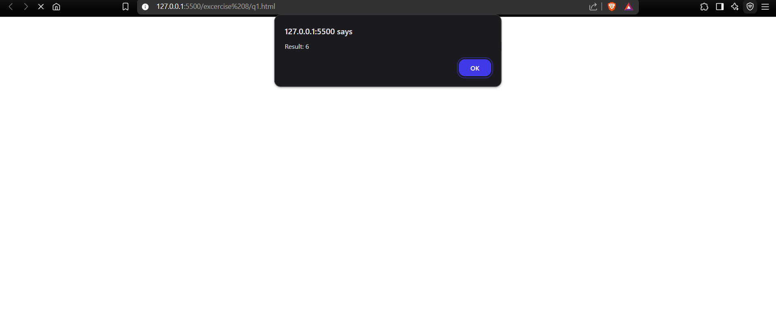

Ques 2:

<!DOCTYPE html>

<html>

<head>

    <title>Driving Eligibility</title>

    <script>

        function checkEligibility() {

            let age = prompt("Enter your age:");

            age = parseInt(age);

            if (age >= 18) {

                alert("You are eligible to drive.");

            } else {

                alert("You are not eligible to drive.");

            }

        }

    </script>

</head>

<body onload="checkEligibility()">

</body>

</html>



Ques 3:

<!DOCTYPE html>

<html>

<head>

    <title>Student Confirmation</title>

    <script>

        function confirmStudent() {

            let isStudent = confirm("Are you a student?");

            if (isStudent) {

                let regNo = prompt("Enter your registration number:");

                alert("Registration Number: " + regNo);

            } else {

                alert("Only students are allowed.");

            }

        }

    </script>

</head>

<body onload="confirmStudent()">

</body>

</html>



Ques 4:

<!DOCTYPE html>

<html>

<head>

    <title>Labour Cost Calculator</title>

    <script>

        function calculateCost() {

            const ratePerHour = 45;

            let hoursWorked = parseFloat(prompt("Enter the number of hours worked:"));

            let costOfMaterials = parseFloat(prompt("Enter the cost of materials:"));

            let labourCost = ratePerHour \* hoursWorked;

            let totalCharge = labourCost + costOfMaterials;

            alert("Labour Cost: Rs." + labourCost + "\nTotal Charge: Rs." + totalCharge);

        }

    </script>

</head>

<body onload="calculateCost()">

</body>

</html>

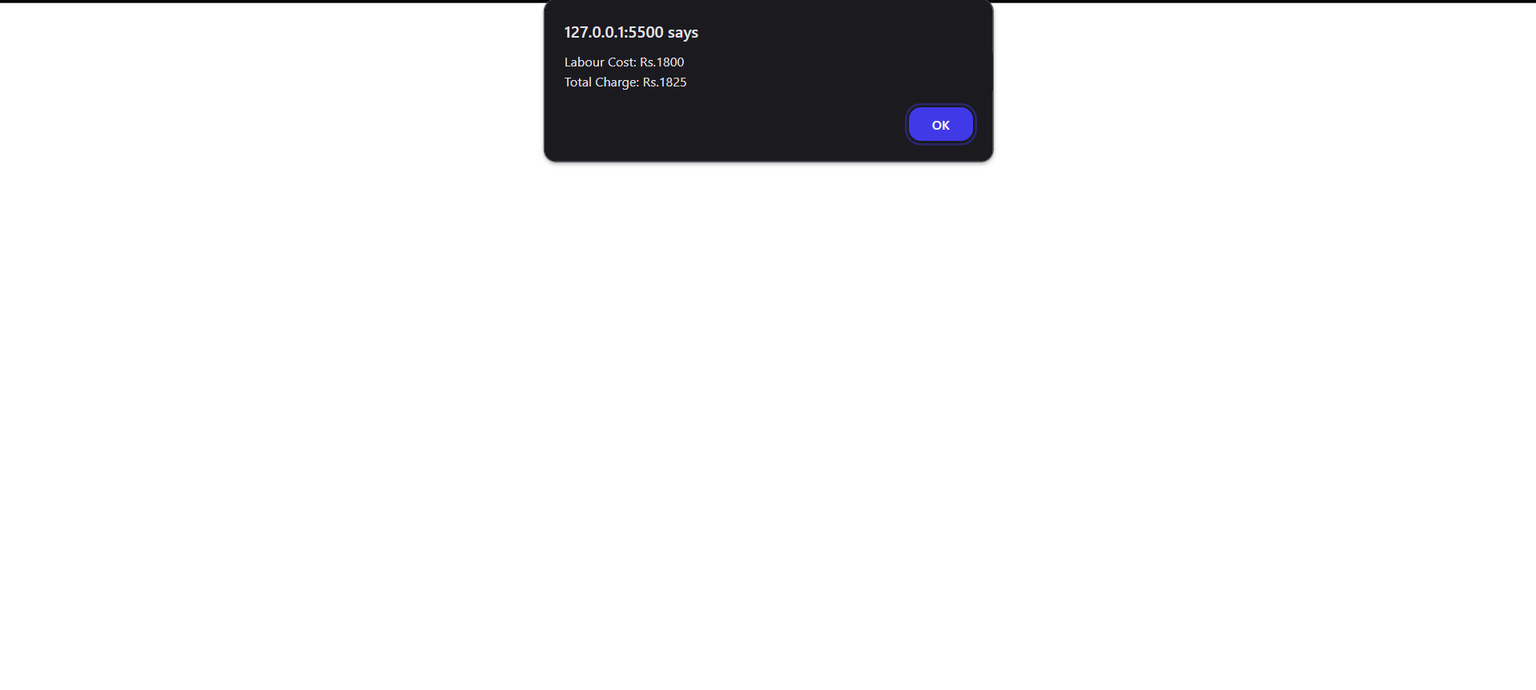

Ques 5:

<!DOCTYPE html>

<html>

<head>

    <title>Display Registration and Name</title>

</head>

<body>

    <script>

        let regNo = prompt("Enter your registration number:");

        let name = prompt("Enter your name:");

        document.write(`<div style="border: 2px solid red; text-align: center; width: 100px; margin: 10px auto; font-size: 20px;">${regNo}</div>`);

        window.onload = function() {

            document.getElementById("nameDisplay").innerHTML = `<span style="color: red; font-weight: bold;">\*${name}\*</span>`;

        }

    </script>

    <div id="nameDisplay" style="text-align: center; margin-top: 10px;"></div>

</body>

</html>



Ques 6:

<!DOCTYPE html>

<html>

<head>

    <title>Ticket Booth</title>

    <script>

        function calculateTotal() {

            let adultTickets = parseInt(document.getElementById("adultTickets").value) || 0;

            let childTickets = parseInt(document.getElementById("childTickets").value) || 0;

            let total = (adultTickets \* 120) + (childTickets \* 60);

            document.getElementById("totalAmount").value = total;

        }

    </script>

</head>

<body>

    <h2>Ticket Booth</h2>

    <label>Adults (₹120 each):</label>

    <input type="number" id="adultTickets" value="0"><br><br>

    <label>Children (₹60 each):</label>

    <input type="number" id="childTickets" value="0"><br><br>

    <button onclick="calculateTotal()">Total</button><br><br>

    <label>Total Amount:</label>

    <input type="text" id="totalAmount" readonly>

</body>

</html>

